Hello and a Happy New Year to you all!

The Art home project for this term is digital photography. This can be done inside however it would encourage the children and give a reason to go outside for a walk or some fresh air as well . It would be brilliant to see lots taking part, I will put together a powerpoint of projects sent in to share with the school at the end of term. All children taking part will receive merits-there will be certificates and a small prize for 1 entry in each year group as well.

The challenge is to be ‘Pattern and Texture’ detectives.
They will need to look around their environment, indoors and outdoors. Encourage them to touch surfaces to experience the textures and look out for natural patterns and patterns made by people-e.g footprints. Materials they could photograph might include:
• Fabric, paper, cardboard.
• Natural materials like slices of wood, bark, leaves, stones or moss.

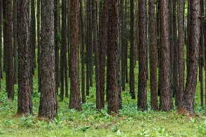
• Objects or things with patterns in their structure like baskets, sieves or colanders, even pets, clothes, food furniture!

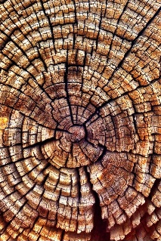
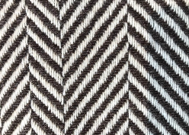


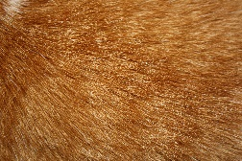

Children could also research a photographer’s work (with you) and create a poster/leaflet/powerpoint about them if they wish to!
Please do check images/websites are appropriate.
Harold Egerton was a scientist who’froze time’ to capture split second images, such as a drop of milk or a bullet through an apple, motions that would otherwise be invisible to the human eye. Harold Edgerton: The man who froze time - BBC Future
Rathika Ramasamy is a wildlife photographer whose timing and eye for detail captures spectacular images of nature in action.
Ansel Adams was a landscape photographer whose use of black and white photography highlighted the vivid shapes, textures and tones of the landscape without the distraction of colour.
Takehito Miyatake is a contemporary photographer who uses a long exposure to create patterns from nature, such as a swirling night sky.

Helping your child use a camera/ take photographs
- You could use cameraphones, tablets, iPads or digital cameras to take the photographs. If the children haven’t used these devices to take photographs before, explain that they need to be held carefully and the screens touched gently.
- Spend some time playing with the devices to find out how they work Help the children to open the camera app if it’s a phone or tablet. Encourage them to find out where the lens is on the device, then to look through the viewfinder or at the scree and move the camera to see what changes. Experiment with taking some photographs. Practice tapping the shutter button while holding the camera still to take a photograph.
- Encourage them to move close until they can see when the image goes out of focus, then pull back until it is sharp. Remind them to frame their photographs tight on their subject, cropping out anything else.

