Stanion CE (Aided) Primary School
Design Technology Policy
‘Each child at Stanion will be enriched, motivated and challenged by a broad and balanced curriculum and will be valued for all their efforts and achievements.” Our approach to delivering the best for every member of our school community is based upon five key curriculum drivers. These are known as our Superpowers.

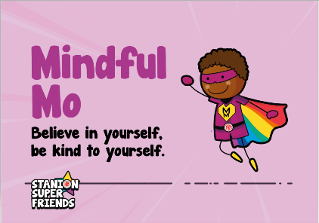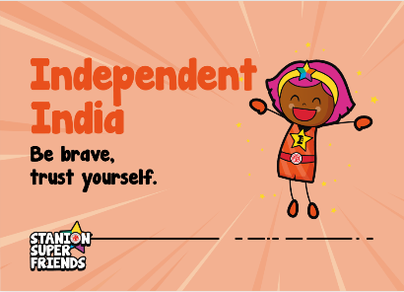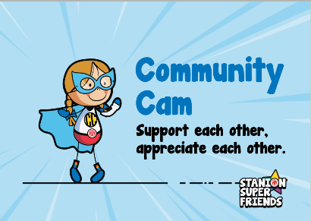
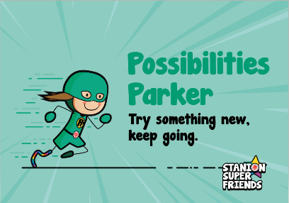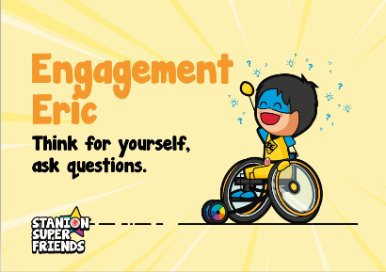
Introduction

“Design and technology is a phenomenally important subject. Logical, creative and practical, it’s the only opportunity students have to apply what they learn in maths and science - directly preparing them for a career in engineering.
James Dyson, Design and Technology Association Patron.
Design and Technology (DT) is a subject that brings together learning and experiences from three main areas:
1. Creative and original thinking: children are encouraged to use their problem-solving skills and imagination, and to feel confident in taking their own original ideas from conception to reality when designing and making their products.
2. Practical skills: children are taught the skills needed in order to successfully create appealing and functional products. They will develop these skills as they progress through school.
3. Scientific and mathematical knowledge: children are taught that ‘technology’ means using what we know about science to make useful things. They are encouraged to see the links between what they may have learnt in Science or Maths and what they can design and create in DT.

Intent

Our overall intention is to build a Design and Technology curriculum which develops learning and results in the acquisition of knowledge and skills. Children will know more, remember more and understand more. We have designed a Design and Technology curriculum with appropriate subject knowledge, skills and understanding as set out in the National Curriculum Design and Technology Programmes of study. We keep this under constant review and strive to make it relevant, engaging and comprehensive.
When delivering the DT curriculum, teachers aim to expose children to a variety of real-world contexts, by learning about influential designers of past and present, and exploring case studies which show how key designers and key moments in design have impacted upon the world we live in. We will provide opportunities to discover how design & technology has met the needs and wants of consumers in the past, how they have changed and why and how those needs are met today. Design & Technology provides opportunity to appreciate the diverse and changing needs and wants within society.
Through this, DT is brought to life and placed in a meaningful context which aims to not only help children know, remember and understand more, but also to encourage our young people to begin to imagine and consider further learning or careers in STEM fields.
Within design & technology our intention is to draw on knowledge from other areas of learning including maths, English and computing and to provide a meaningful context in which to embed and apply cross curricular skills. Out Design and Technology projects are closely linked with our topics as stated on the long term plans. The Design & Technology curriculum intends to equip children the confidence, attitudes, skills and knowledge to become successful, reflective designers and makers of products.

Finally, we strive to create a love of the subject through engaging lessons, visitors and larger collaborative projects. Some of the projects children have taken part in are shown below;

Year 5 and 6 experimenting with bridge building techniques.
A textiles project exploring joining techniques. Year 1 and 2 put together a class coat of arms using the skills they had learnt.

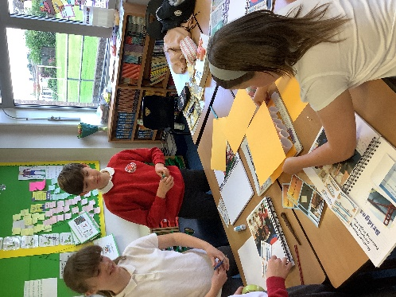
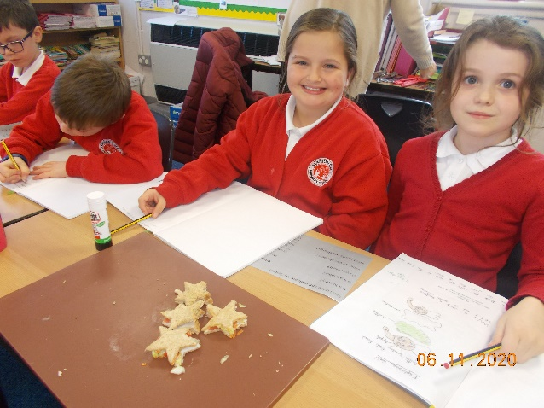
Year 3 and 4 Food Technology
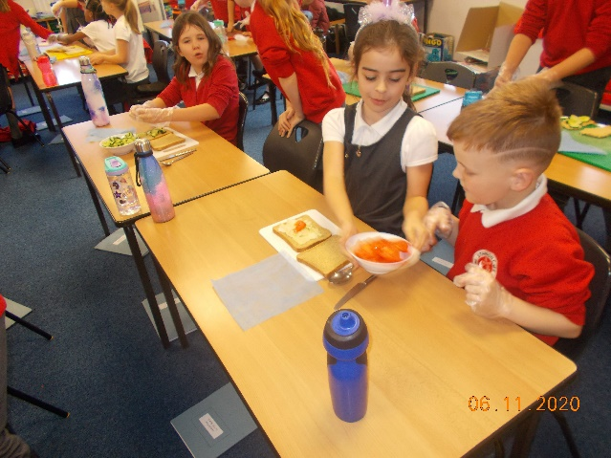

A visit from ‘Chicken Wired’ in June 2021 saw children building their fine motor skills and using tissue paper creatively.
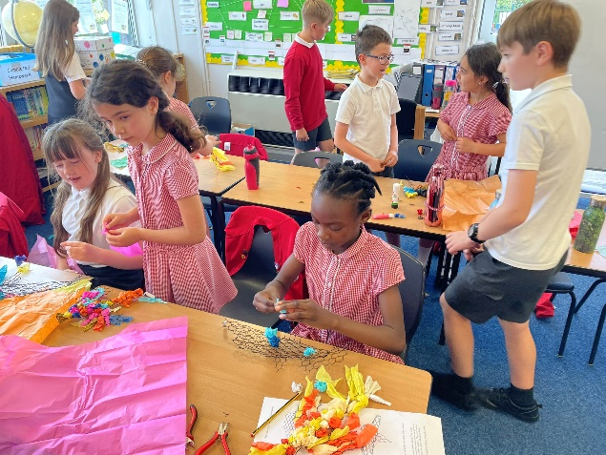
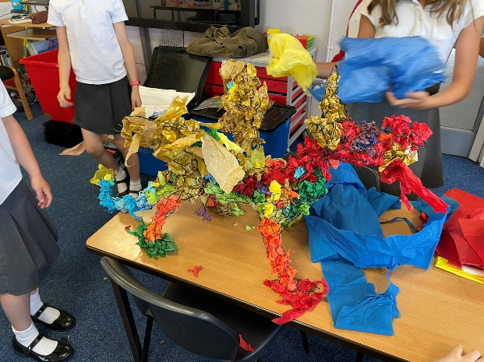

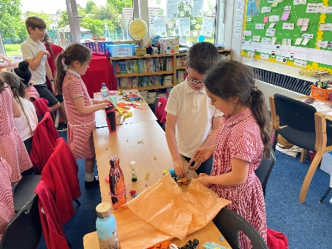

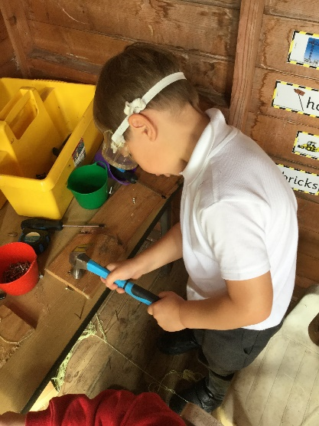
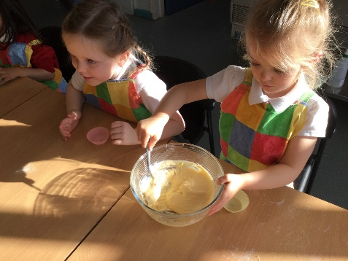
Our reception children building their practical skills in the continuous provision areas and taking part in cooking activities.

Implementation

We have a clear and comprehensive long term plan which is in line with the National Curriculum. The DT National Curriculum and EYFS is planned for and covered in full within the EYFS, KS1 and KS2 school curriculum. Whilst the EYFS and National Curriculum forms the foundation of our curriculum, we make sure that children learn additional skills, knowledge and understanding and enhance our curriculum as and when necessary.

EYFS
Early Years Foundation Stage Design and Technology falls within the ‘Expressive Arts and Design’ strand of the EYFS.
Children are given the opportunity to: •Manipulate materials to achieve a planned effect. •Construct with a purpose in mind, using a variety of resources. •Use simple tools and techniques competently and appropriately. •Select appropriate resources and adapt work where necessary. •Select tools and techniques needed to shape, assemble and join materials they are using.
We encourage the development of creativity, skills; knowledge and understanding that help children make sense of their world. We relate the development of the children’s arts and design to the objectives set out in the Early Learning Goals. This learning forms the foundations for later work in design and technology.
We provide a range of experiences and adult led learning activities that encourage creativity, exploration, observation, problem solving, critical thinking and discussion. The children also have access to a variety of tools and resources within continuous provision which enable them to build on their practical skills. Every opportunity is taken to model correct techniques and support children in their problem solving ( E.g how can I fix this together so it is strong enough to play with?), as children are exploring and learning independently.
Within our EYFS we foster the Characteristics for Learning (exploration, active learning, and critical thinking) and provide opportunities for Expressive Art and Design, and Understanding the World which equips our youngest children with the attitudes and experiences on which our curriculum for Design & Technology is built. The rich and varied projects and experiences our reception children take part in are detailed on the school long term plan.

The National Curriculum

The National Curriculum prescribes that at Key Stage 1 pupils should be taught:

Design • design purposeful, functional, appealing products for themselves and other users based on design criteria • generate, develop, model and communicate their ideas through talking, drawing, templates, mock-ups and, where appropriate, information and communication technology

Make • select from and use a range of tools and equipment to perform practical tasks [for example, cutting, shaping, joining and finishing] • select from and use a wide range of materials and components, including construction materials, textiles and ingredients, according to their characteristics

Evaluate • explore and evaluate a range of existing products • evaluate their ideas and products against design criteria

Technical Knowledge • explore and use mechanisms [for example, levers, sliders, wheels and axels], in their products • build structures, explaining how they can be made stronger, stiffer and more stable.

National Curriculum - Key Stage 2
Design • use research and develop design criteria to inform the design of innovative, functional, appealing products that are fit for purpose, aimed at particular individuals or groups • generate, develop, model and communicate their ideas through discussion, annotated sketches, cross-sectional and exploded diagrams, prototypes, pattern pieces and computer-aided design
Make • select from and use a wider range of tools and equipment to perform practical tasks [for example, cutting, shaping, joining and finishing], accurately • select from and use a wider range of materials and components, including construction materials, textiles and ingredients, according to their functional properties and aesthetic qualities
Evaluate • investigate and analyse a range of existing products • evaluate their ideas and products against their own design criteria and consider the views of others to improve their work • understand how key events and individuals in design and technology have helped shape the world
Technical knowledge • apply their understanding of how to strengthen, stiffen and reinforce more complex structures • apply their understanding of how to strengthen, stiffen and reinforce more complex structures • understand and use mechanical systems in their products [for example, gears, pulleys, cams, levers and linkages]

Planning and teaching
Planning and teaching Design & Technology is a varied process, encompassing individual lessons, blocks of teaching and class or whole school projects. Topic linked planning inspires and enthuses children to critically evaluate products and understand changes in design and technology. We use ‘Projects on the page’ and KAPOW as a basis for our own planning to ensure skills progression and then adapt the content to suit our children. This enables our curriculum to be flexible in content whilst keeping in mind the importance of skills progression over the longer term.

- We teach skills explicitly, from EYFS to Y6. These link with our engaging, topic based curriculum. We have identified key skills and concepts within all key stages to ensure that children are challenged and have the chance to develop as artists and designers. These skills form the basis of our long and medium term planning and are reviewed annually to ensure they are relevant and reflect what our children need to and learn and develop. Please see attached skills progression and long term plan documents.

- Every opportunity is taken to use the work of great designers, past and present, in order to learn and master artistic processes. These will be identified on our long term plans and are reviewed regularly.

- Throughout the projects, children are exposed to rich vocabulary within meaningful contexts. Staff have access to a glossary of terms relevant to each year group and we ensure we use the correct technical language when teaching Design Technology. Expanding the language our children use is something we prioritise across our whole curriculum.

- Design & technology is creatively linked with subjects including history and art & design and supports the development of skills in reading, computing, maths and science. A Year One and Two project to design a textiles square for a Coat of Arms, enabled enrichment opportunities of understanding events beyond the children’s living memory. It led to discussion of how symbols were used in place of writing long ago as much of the population couldn’t read. They then identified where symbols are used nowadays, for example the ‘M’ on Macdonald’s and care badges etc.

Assessment and record keeping.

- Assessment and feedback to pupils is usually carried out by observation and oral feedback during lessons. All children have a sketch book in which to record Art and Design Technology learning. Staff will take photographs and store them in the Design Technology subject file for their class. Children may annotate their sketch books or add post-it notes with what they have learnt and evaluations of their work or that of others. Staff may write these for children too.

- Each sketch book is personal to the child and staff will encourage creativity within a framework of expectations. Children will treat their books with respect and take pride in their learning. A short date should be written in so that work can be matched up to planning for assessment purposes. New units should have a title page- this can be created by the child. Design Technology units should have a skills grid to refer to over each unit of work. This will support children in evaluating their learning and that of others where appropriate. Sketch books are not marked as it is intended that children will have ownership of them and feel free to take risks and experiment. In KS2 staff may decide to use a more comprehensive ‘ knowledge organiser’ in sketch books although all staff will have the appropriate language and objectives embedded within their short term planning (powerpoint) anyway.

- Planning is annotated in order to inform next learning steps and for assessment purposes. Progression and achievement is tracked 3 times a year against our skills progression grids which we also use for planning from. We aim to moderate assessments in a staff meeting once a year and use our big books to help us look at progression across the school too.

- Reception children are baseline assessed at the start of the year and their Early Learning Goals profile is updated throughout each term. Reception evidence work through the use of tapestry. Pupil comments are annotated on tapestry.

Subject leader

- The monitoring of the standards of children’s work and of the quality of teaching in art and design technology is the responsibility of the subject leader. The school’s appointed subject leader will oversee the continuity of the subject and the progression of teaching and learning within annual and medium-term plans.

- They will ensure that;

- An action plan is produced at the beginning of each academic year and an annual summary report evaluating the strengths and areas for further improvement.
- Ensuring that the Scheme of Work allows for full coverage of EYFS/NC objectives and shows progression across school.
- Monitor teachers’ planning, look at childrens’ sketch books, speak to children at least once a year about their learning, conduct learning walks once a year. Provide feedback to staff on all monitoring activities in order that teaching and learning may be improved and celebrated too.

- Keep track of resources and aim to create a full list of resources required for each unit of work.

- The work of the subject leader also involves being informed about current developments in the subject, providing a strategic lead and direction for the subject in the school and supporting colleagues. The subject leader will maintain a bank of lesson planning ideas, resources and digital demonstration videos in order to give staff full confidence teaching Design Technology.

Inclusion and Equal Opportunities
All teaching and non-teaching staff at Stanion are responsible for ensuring that every pupil, regardless of gender, race, culture, background and ability have the opportunity to experience education at an appropriate and challenging level. To ensure that pupils experience high standards of success, Design Technology needs to be taught with regards to pupil’s abilities to ensure progress. We aim to identify and minimise barriers to learning and take account of gender, ability, disability, social, cultural, and linguistic background when planning lessons.

Provision is made to enable all pupils to participate effectively in curriculum and assessment activities. A wide range of gender specific and cultural images that challenge stereotypes will be used. This policy ensures that certain aspects of the subject are not seen as more appropriate for boys or girls.

SEND
We teach Art to all pupils, whatever their ability, in accordance with the information set out in our school curriculum overviews, providing a broad and balanced curriculum to all. Teachers provide learning opportunities matched to the needs of children of all capabilities. Advice can be sought from the school's SENDCO where applicable.

We aim for all learners to make expected progress from their starting points. All learners, including SEND pupils, benefit from the use of good quality resources to deepen understanding and support their progression.

Pupils are supported through the use of wordbanks and visual prompts during lessons. Subject specific vocabulary is mapped by year group and explicitly taught to learners.

We recognise that differentiation through the use of different tasks risks widening gaps between pupils in the class. Often, differentiation is provided through the use of resources, scaffolding of tasks, use of mastery questions to deepen thinking and the amount of support and guidance given to complete tasks. Differentiation by outcome can allow all children to access a task and respond individually at the level appropriate to them.

Health and Safety
Food Technology: Children will be instructed on how to use sharp knives safely and will be supervised while using them. Children will be instructed on how to use a hob/oven and will be supervised when using. Food hygiene will be covered in each year group as a key learning objective for each Food Technology project. Teachers must familiarise themselves with any food allergies or dietary requirements within their cohort and plan accordingly.
Using tools: Children will be shown how to use a variety of tools safely and staff will oversee use of tools, with levels of supervision appropriate to age of children. Staff will ensure pupils have a tidy environment and enough space to work safely within. They will also set high expectations of responsible behaviour in DT lessons
Impact

Children will know more, remember more and understand more about DT. The large majority of children will achieve age related expectations in DT. As designers, children will develop skills and attributes they can use beyond school and into adulthood.

The impact of our design & technology is measured through our monitoring cycle, which includes book looks where applicable, digital evidence, learning walks, pupil voice and planning scrutiny. Upon review, action points are discussed and agreed with individual teachers to implement. We assess and track design & technology against skills and knowledge which are differentiated for each year group. Through these actions all stakeholders are aware of progression and next steps for individuals and cohorts.

The intended impact of our Design & Technology curriculum is outlined below:
- Children can articulate and explain what Design & Technology is.

- Children demonstrate originality and willingness to take creative risks to produce innovative ideas. Children can carry out research, show initiative and ask questions to develop a detailed knowledge of a user’s needs.

- Children can act as responsible designers and makers, working ethically, using finite materials carefully and working safely. As a school we feel strongly that using resources thoughtfully and respectfully is a key way in which we can look after our planet.

- Children have a good knowledge of which tools, equipment and materials to use to make their products. They can manage risks to manufacture products safely and hygienically.

- Children have a passion for the subject and knowledge of, up-to-date technological innovations in materials, products and systems.

