Super Friend curriculum driver
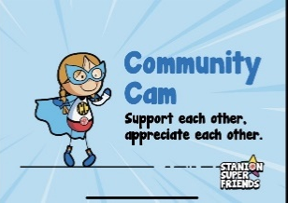
Art | Appreciate their own Art and that of others. Children are exposed to a wide variety and diversity of Artists from across history and the globe. Children begin by offering guided positive feedback to each other and gradually progress to giving constructive feedback using appropriate subject specific vocabulary. Children feel supported to be creative and able to take risks in their Art as a result.
DT | Consider the impact a product may have on the community/ target audience. Appreciate the needs of others when designing a product. Support each other in practical work by offering feedback and ideas on how to improve products. When working in pairs or groups children will develop their ability to work as part of a team. They become aware of the importance of teamwork in design and production.

Super Friend curriculum driver
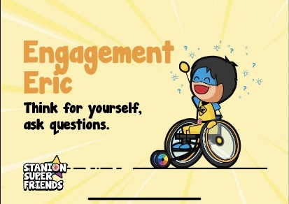
Art | View, discuss and appraise a diverse range of famous Art. Children are enabled to comment on a range of Art through the use of wordbanks and sentence starters. They are encouraged to give their opinions and reasons why they like or dislike Art. Children are aware there are no right or wrong answers so feel confident to ask questions about the Art they are viewing. In practical work children learn to try and practice a range of techniques, they compare their ideas to those of others and question what else/ how else things can be done.
DT | Children learn to question the needs of the target group when designing a product. As they design and make they continually question whether they are meeting their design brief effectively and review/ adapt in light of this.  In practical work children try out and practice a range of techniques and skills, they compare their ideas to those of others and question what else/ how else things can be done.

Super Friend curriculum driver
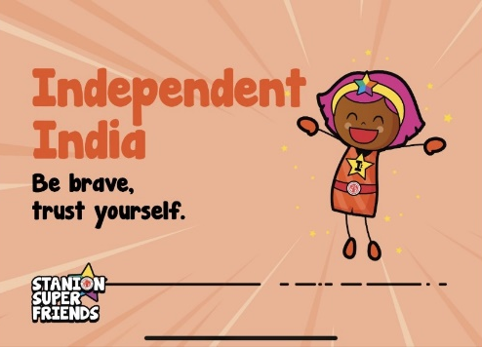
Art | Enjoy tackling new skills and using new materials independently. Make creative decisions about their Art such as which colours/ proportions/ materials to use. Independently think about and collect what they need for a project. Be brave when trying out new ideas and appreciate the process in Art is just as important as the finished product.
DT | Think about and suggest ideas for designing and making. Make original suggestions without concern that others may not have the same ideas. Children trust themselves to use tools and techniques safely and accurately.

Super Friend curriculum driver
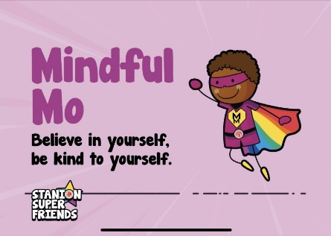
Art | Understand that the process of creating Art is the most important thing. Understand that their finished piece will not always please them and learn to appreciate what they have learnt/ gained from a project. By learning about the lives of famous Artists children learn to appreciate the value of perseverance, hard work and belief in oneself. Many artists did not become famous until long after their deaths. Through this knowledge children begin to see the value of doing things for what they themselves gain not just to gain praise from others.
DT | Explore significant individuals who are relatable and inspiring. Understand that mistakes and setbacks are integral to the design of any product. This process is how products are improved upon and refined. Believe in and have confident=ce in their ability to solve design problems.

Super Friend curriculum driver
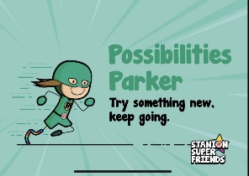
Art | Be open to exploring a variety of art styles e.g abstract/ realistic/ surreal/ impressionist. Learn about, try out and evaluate a range of materials and techniques. Children are supported to be creative and explore in Art with a focus on process and learning.
DT | Understand how a new product impacts on a group of people/ community and their lifestyles. During the design process consider the possibilities and uses their product will have. Understand and be excited by the impact of new technologies throughout history and going forwards.

